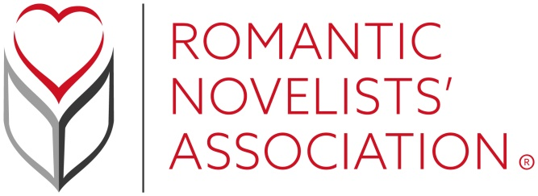

We're passionate about creating an inclusive RNA that promotes and values diversity. Romantic fiction portrays all types of people. We're on a journey to ensure the RNA does too.

RNA New Writers’ Scheme Policy
The role of the NWS is to assist members in their goal to become published writers. There are two parts to this role. One is to offer advice and mentoring on the craft of writing. The second is to help new writers better understand the publishing industry and how to work within it.
The scheme is open to unpublished writers of romantic fiction in all genres. Members of the New Writers’ Scheme can participate in all the RNA’s activities and events and can submit one manuscript of an unpublished novel (self-published novels are not eligible) for critique each year. The Scheme opens in January each year and can accept only 300 members.
All books entered into the scheme must fall within a broad definition of Romantic Fiction: that is to say, an exploration of romantic love must form an important element of the plot or a major sub-plot of the story. All genres of fiction with strong romantic elements are welcome. The ending of a romantic novel will commonly be uplifting. The RNA does NOT consider stalking, non-consensual intimacy, physical or mental abuse or coercion to be romantic. Erotic role playing incorporating these elements is acceptable, but only if consent is clear. The novel may incorporate any of these elements, but they should not be portrayed as part of the romantic relationship.
Any novel where these elements form part of the 'romantic' relationship will be disqualified. If a submission is disqualified, no refund will be given. The NWS coordinators decision on eligibility will be final.
Members may submit a partial or completed manuscript of a novel. The maximum length for a submitted MS is 100,000 words. The minimum length for a partial is 10,000 words. MS outside these lengths will not be read and no refund of fees will be given. The same manuscript may be submitted more than once, but only once per membership year. It is recommended that the same MS be submitted no more than three times.
If a submission does not meet the published submission guidelines, the organiser may ask the member to modify and resubmit their entry. Any re-submissions must be done before the closing date.
Submissions will be via the RNA’s online system between dates specified each year by the organiser. These dates are fixed and no exceptions will be made. If no manuscript is submitted, there will be no refund.
All NWS reports will be anonymous. The reader will not identify themselves in their report, nor will the RNA identify the reader to the writer of the MS. All communications between reader and writer will be via the scheme organiser. All readers will be Full members of the RNA. Should they choose, readers may identify themselves to members at a personal level.
Entries will be assigned to appropriate readers at the discretion of the NWS Organiser. Members may request their MS be sent to a reader from a previous year, or a different reader. Members may also request a reader with experience in a specific market e.g. Mills & Boon. The organiser will do their best to meet these requests, but there is no guarantee that this will be possible. Members may not request a specific reader by name.
If a reader feels unable to objectively assess a MS due to genre, character or subject matter, they should contact the organiser who will reassign the MS to a different reader.
If a reader feels the book does not meet the published submission guidelines, the reader should contact the scheme organiser.
Readers will not discuss the scheme or manuscripts they have read on their social media platforms.
Readers will provide a report written by them. This report may include an annotated copy of the submitted MS. The organiser will ensure all documents are anonymous before passing them through to the member. The organiser will also ensure they fulfil RNA policy in terms of content.
The NWS does not purport to be a copy editing service. Readers will not copy edit the manuscript.
Readers will delete all submitted works from their computers and other devices at the end of each NWS year.
The Organiser will advise and support authors whose report indicates that their novel is ready, or almost ready, to be submitted to a publisher or agent.
Current scheme members will be given first opportunity to sign up for the next year’s scheme. If a member does not submit a MS, they will still be offered a chance to re-join the following year. However, beginning in 2022, any member who has not submitted for three consecutive years will not be given a priority place the following year, although they may still join when membership opens to the public. Members may not defer their membership and retain a reserved place.
If a manuscript entered into the NWS subsequently gains a contract with a recognised publisher and is the member’s debut novel, it may be eligible for the Joan Hessayon New Writers’ Scheme Award. In order to be eligible, the author must have remained a member continuously since the MS was submitted to the NWS. It is the author's responsibility to notify the RNA when they receive an offer of publication.

