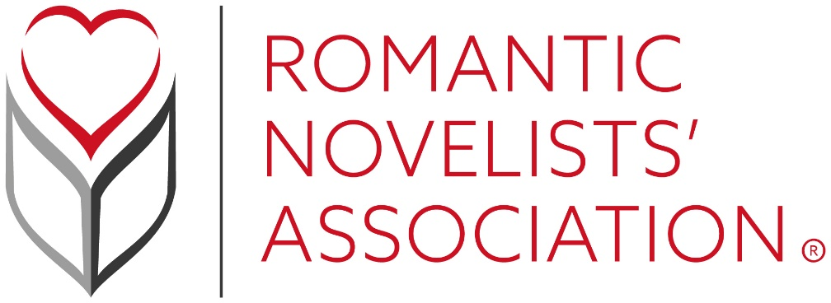
Romance Reading Month 2021
Celebrate Romantic Fiction this February with the Romantic Novelists’ Association
Due to the success of the inaugural Romance Reading Month in 2020 which took place when things were still relatively normal in the world, the Romantic Novelists’ Association have decided to do it all over again this February. The aim of the month is to raise awareness of and celebrate Romantic Fiction in all its beautiful forms, explore the various sub genres and share widely the diversity amongst romantic authors, stories, characters and themes.
The month will start with an exciting announcement of the short-listees for the Romantic Novel Awards which will take place in early March. The newly launched RNA Learning courses begin in February with the first one being ‘All you need is a six pack’ by Anna Sugden which provides writers with advice on how to develop a toolkit that works for them.

The Romantic Novelists’ Association would like to take this opportunity to support their allies in libraries and bookshops. Libraries are a fantastic resource for communities, and did you know that every time you borrow a library book then an author gets their wings? Well, that’s not quite true, but they do receive a small remuneration, and after all every little helps.
Week 1 from the 1st -7th February will be Love My Library Week where normally readers would be encouraged to borrow library books and tweet pictures of their haul to @RNAtweets, but under the current circumstances with libraries being closed the RNA would like to hear about your library stories, did you fall in love in a library? Or maybe a librarian helped to change your life in some way. Make sure to tag your local library too using the hashtag #LoveMyLibraryWeek.
Week 2 from the 8th – 14th will be a celebration of independent bookshops. Bookshops have suffered terribly throughout the pandemic, and this is a chance for everyone to help support their local. The RNA had hoped that bookshops would be open again by now so that readers could buy romance books and share their pictures across social media but unfortunately that wasn’t to be. Therefore please support your local bookshop by tweeting about your bookshop heroes and stories and what it is you love about them to @RNAtweets using the hashtag #LoveMyIndieBookshopWeek You could also try ordering from them online and next time they open why not buy book tokens for Christmas and birthday presents?
Week 2 also includes an exciting opportunity for members of the RNA: from 8pm on Friday 12th – 8am on Monday 15th Simon and Schuster will be inviting submissions exclusively from RNA members for their #DigitalOriginals initiative. Here’s the link for more information http://booksandthecity.co.uk/rnaoneday/

Week 3 from the 15th – 21st will be focusing on the diversity of Romantic Fiction with celebrations of authors, characters and stories from under-represented groups to show that love stories are for everyone and every body. On the 15th the Rainbow chapter will be recommending books by LGBTQIA+ authors and will be taking part in a live panel on the main Romantic Novelists’ Association’s Facebook page, time to be confirmed. The Rainbow Chapter can be followed on twitter @RNARainbow, and the DISCO chapter @RNAdisco.
On the 17th the spotlight will be shining on romance books by and about people of colour and members from the RNA will be featured on a panel talking about their favourite authors and books, time to be confirmed.
To round off the week on the 19th the DISCO Chapter will be celebrating by shouting about books by people living with disabilities/chronic conditions or writing characters with those conditions. To find out more about all of the above please follow the hashtag #RNADiverseLoveWeek
The final week from 22nd – 28th will be a celebration of romance authors and book bloggers in general, with the 22nd being a day where members of the organisation can tweet @RNAtweets describing in one sentence what the RNA means to them using the hashtag #TheRNAAndMe
Author, book blogger and head of publicity at Bookouture Kim Nash will be interviewing a panel of award-winning book bloggers at 7pm on the 24th live from the RNA Facebook account so tune in to find out what it’s like to be a blogger and what they look for in a protagonist and a leading man. The 25th will be a day to share your favourite books by independent authors using the hashtag #RNAIndieAuthors. There will also be author, blogger, librarian and bookseller interviews on the RNA blog throughout the month.
If you have any ideas for the month and would like to get involved, please email annettehannah@romanticnovelistsassociation.org
For more details about Romance Reading Month or about the Romantic Novelists’ Association please visit the website www.RomanticNovelistsAssociation.org

Calendar of Events:
1^{st -} Announcement of shortlistees for Romantic Novel Awards
RNA Learning Courses starting
1st- 7th #LoveMyLibraryWeek
8th -14th #LoveMyIndieBookshopWeek
15th – 21st #RNADiverseLoveWeek
15th - Rainbow Chapter Celebration, share LGBQT+ books, authors and characters using the hashtag above.
17th – Black, Asian and Minority Ethnic Celebrations, share books by BAME authors and/ or featuring BAME characters.
19th – DISCO Chapter Celebration share books by people living with disabilities/chronic conditions or writing characters with dis/cc @RNADISCO
22nd – 28th #RomanceReadingMonth #AuthorsAndBookBloggersWeek

