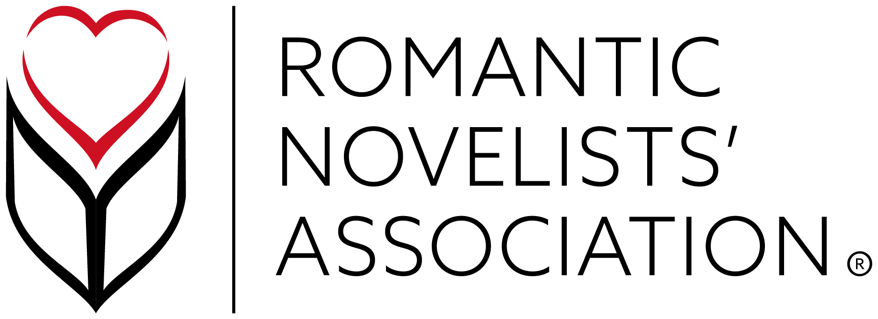

RNA VIRTUAL MINI CONFERENCE 2021

THURSDAY July 15th 2021

15:00 Practice Makes Pitch Perfect
Ever wanted to give your elevator pitch a pain free trial run in front of industry professionals? Now's your chance to not only pitch live to three agents, but to receive immediate feedback and tips on how to truly captivate.
Join Blake Friedmann Agency's Juliet Pickering, Kate Burke and Sian Ellis-Martin to fine tune your pitch so that when we are finally allowed back in elevators, you are ready to go!
To participate, please email Sheila Crighton (sheilacrighton@me.com). Approximately ten people will be chosen for this fascinating, live session.

FRIDAY July 16th 2021

10:00 AGM
10:00 - 12:00 One-to-Ones
14:00 - 16:00 One-to-Ones

SATURDAY July 17th 2021

09.30 Building Writer's Resilience Dinah Jeffries & Nicola Cornick
As writers we’re often plagued by self-doubt, lack of confidence, and imposter syndrome, but we have to learn to develop resilience. Writing and publishing can feel like being on a roller coaster of ups and downs, of wins and losses, so how do we recover from, or successfully adapt without caving in? How do we bend rather than break?

10.45 An A - Z of Agenting Felicity Trew (Caroline Sheldon Agency)
Felicity will run a comprehensive two part workshop on a day in the life of a literary agent and how you can hook one. This fun, inspiring and practical workshop covers what a literary agent does, how to write a great submission letter and make sure agents want to open your manuscript. The submissions letter is the first example of your writing an agent will ever read, so getting it right is make or break. From dissecting the DNA of the perfect letter to analysing examples of the good, the bad and the ugly, this session will help you perfect the tricky art of pitching yourself and your work.

Noon The Proposal: Structuring Your Rom Com to Create Movie Magic Marie Macneill
Have you ever thought that your novel could be written for the big screen? Screenwriter and Senior Lecturer at Falmouth University's School of Film & Television, Marie Macneill, takes you on a romp through the 317m dollars box office hit and discovers the plot points, beats and twists that took cinemas by storm.

14.00 Anatomy of a Scene Fiona Lucas
What exactly is a scene? And how do you make sure every scene packs a punch, earning a place in your novel? In this session, Fiona Lucas will be stripping this vital building block of fiction down to its bare bones. Learn how to revive a scene that is flatlining and how to make sure it will end on a hook that will keep readers turning pages!

15:15 Digital Publishing: The Five Ws Rhea Kurien
If you've heard about Digital publishing but aren't quite sure what it is, why it's a thing or how it might work for you if you're already a published author, please join Rhea Kurien, Editorial Director at Orion Dash. She will explain exactly how digital publishing works as well as sharing a few tips and tricks on how to make publishing work for you whether you are new on the scene or a seasoned author.

16.30 CONFERENCE HIGHLIGHT: Beverly Jenkins: Interviewed by Dorothy Koomson
Two writing powerhouses: One mustn't miss conversation. Join us as Dorothy Koomson interviews writing legend Beverly Jenkins for her podcast The Happy Author.

Speaker Bios - in order of the talks

Juliet Pickering
Juliet Pickering proudly represents a list of intriguing, conversation-starting, diverse writers, across both fiction and non-fiction. She loves bringing an under-represented experience to both editors and readers. She’s a proud feminist and loves books that empower, make us feel recognised and heard. She’s drawn to rich and multi-layered stories of women, families, friendships and relationships, and love in small communities with a strong setting and lots going on beneath the surface.

Kate Burke
Kate Burke was an editor for three major publishing houses for ten years before becoming an agent. She loves gripping fiction featuring characters readers can't get enough of and is always on the hunt for engagingly dark novels, uplifting love stories and page turning thrillers all of which reflect the diverse world in which we live.

Sian Ellis-Martin
Sian Ellis-Martin is Assistant to Isobel Dixon and Kate Burke. She is starting to build her own list and is looking for books from a diverse range of authors in both fiction and non-fiction. In fiction, she loves gripping plots, characters you wish were real, and stories with a perspective or setting we may not have seen before. She is particularly keen to read LGBTQ+ stories and authors.

Dinah Jeffries
Dinah Jefferies began her career with The Separation, followed by the number 1 Sunday Times and Richard & Judy bestseller The Tea-Planter’s Wife. Born in Malaysia, she moved to England at the age of nine. After 7 books with Penguin, she is now writing a trilogy for Harper Fiction, the first of which, Daughters of War, will be published in September. She is published in 28 languages and over 30 countries, has been a Sunday Times top ten bestseller 4 times, and has twice been a Richard & Judy Book Club pick.

Nicola Cornick
Nicola Cornick is an international bestselling and award-winning writer who has written over thirty historical novels in a career spanning twenty years. Nicola studied History at the University of London and at Ruskin College Oxford and worked in academia for a number of years before becoming a full-time author. She volunteers as a guide and researcher for the National Trust at the 17th century Ashdown House and is a trustee of the |Friends of Lydiard Park and the Wantage Literary Festival. Nicola enjoys giving talks on a number of historical and writing topics. Her most recent novel, The Forgotten Sister, is published by HarperCollins. Her next book The Last Daughter is a dual time novel set in the present and the Wars of the Roses, and is out in July 2021. In her spare time, Nicola raises guide dog puppies.

Felicity Trew
Felicity Trew devours contemporary and historical fiction as well as quirky and imaginative children's books. Dream projects that would arrive on her desk include a spellbinding novel for our time, a bold, contemporary UK teen voice, an accessible, well-plotted (and don't hold back on the funny) book for middle grade. She is an unremittingly passionate advocate of those she represents and loves the challenge of finding the best home for her authors in the market. She is delighted to be one of The Bookseller's Rising Stars in 2016.

Marie Macneill
Marie Macneill is still a member of the RNA's NWS and has two novels tucked away in a drawer. This is mostly because she teaches screenwriting full-time and is also currently writing END OF THE LINE, a 6-part TV series for Cornish Voices, BBC Writers' Room and THREE STORMS, a film set on Falmouth's Castle Beach.

Fiona Lucas
Fiona Lucas writes contemporary women’s fiction. The Last Goodbye is her first novel written under this name, but she’s been writing heartwarming love as Fiona Harper since 2006. During her career, she’s won numerous awards, including the RNA’s Joan Hessayon New Writers’ Award and a RoNA. Fiona lives in London with her husband and two daughters.

Rhea Kurien
After working for imprints such as HQ, Headline and Aria, Rhea Kurien is now Editorial Director at Orion Dash, the new digital-first imprint at Orion. She is passionate about women's fiction in all its forms, from romance to saga, and is keen to publish more diverse voices in this area.

Beverly Jenkins
Beverly Jenkins is the USA's premier writer of African American historical romance fiction, and specializes in 19th century African American life. She’s a USA TODAY best-selling author, an NAACP Image Award nominee, and the 2017 recipient of Romance Writers of America’s Nora Roberts Lifetime Achievement Award. She has over forty nine published works, and has been featured in many major publications including the NYT, People Magazine, WSJ, and on NPR and CBS Sunday Morning. She speaks widely on African American history, romance, and writing. Some of her work has been optioned by Sony Television and Al Roker Entertainment.

Dorothy Koomson
Dorothy Koomson is an award-winning, global bestselling author whose novels have been translated into more than 30 languages with sales that exceed 2 million copies in the UK alone. Dorothy’s books are powerful, thought-provoking and compelling ‘emotional thrillers’ where moral dilemmas are central and where the complex emotions of family and friendships are explored. Her third book, My Best Friend’s Girl, was selected for the Richard & Judy Summer Reads of 2006, and her novels The Ice Cream Girls and The Rose Petal Beach were both shortlisted for the British Book Awards in 2010 and 2013, respectively. A TV adaptation loosely based on The Ice Cream Girls. Dorothy actively supports new writers and recently launched The Happy Author podcast. She was featured on the 2021 Powerlist, as one of the most influential Black people in Britain and appeared in GQ Style as a Black British trailblazer. Dorothy lives in Brighton (well, Hove, actually) and the city is an ever-present character in her novels. Dorothy’s 17th novel, I Know What You’ve Done is published in July 2021.

