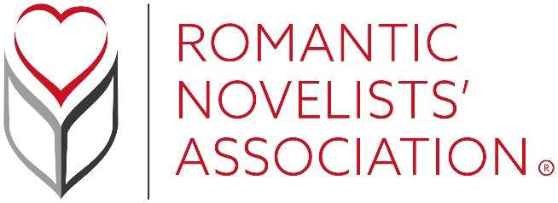

2022 Annual General Meeting
9am, 16th July 2022
Harper Adams University, Edgmond, Newport, Shropshire TF10 8NB
Proxy Voting

If Full, Associate or Honorary members of the RNA are unable to attend the AGM in person, they are entitled to appoint a proxy. If you wish to do so, please complete the form below:

Full name of the member appointing the proxy:
Address of the member appointing the proxy:
The name of the person appointed to be the member’s proxy* at the RNA’s 2022 AGM:

*this person must be a Full, Associate or Honorary member
Signature of the member appointing the proxy:

Please return this form, via email, to the RNA’s Company Secretary, Ali Henderson, alihenderson@romanticnovelistsassociation.org before 9am on Thursday 14th July 2022

